**Lesson Plan Format Guidelines:**

**Paper Size:** **A4** (8.3 x 11.7 in / 21.0 x 29.7 cm); or

**Letter** (8.5 x 11.0 in / 21.6 x 27.9 cm) (US’ standard)

**Margin:** **Top** – 1 in / 2.54 cm **Bottom** – 0.5 in / 1.27 cm

**Left** – 0.5 in / 1.27 cm **Right** – 0.5 in / 1.27 cm

**Front Size:** **Mark Pro** & **Mark Pro Medium**

**Title** (e.g. Lesson 4 Visualizing the Global Warming) – **18 points Mark Pro Medium, Bold Added**

**Heading** (e.g. Objectives/Activities/Section 1 Introduction/…) – **14 points Mark Pro Medium, Bold Added**

**Sub-heading** (e.g. Procedure/Step 1/…; headings within the main content) – **11 points Mark Pro Medium, Bold Added**

**Main content** – **11 points Mark Pro**

Bold added for emphasis when necessary

**Indentation:** not for the main content

**Line Spacing:** 1.5 lines (or 22 points at least)

**Spelling and punctuation:**

American English and rules for North America

British English and rules for the Commonwealth, and the EU

Use **endnotes** rather than footnotes

**Works cited:** Harvard reference, cf. <https://www.imperial.ac.uk/admin-services/library/learning-support/reference-management/harvard-style/>

**Delivery:** PDF

**Introduction**

**1. Pedagogical approach**

With Makeblock Education, the development of knowledge and skills is the combination of digital and physical tools that work together to provide a hands-on learning experience. Students actively engage with the lesson’s topic in order to solve a problem or create something new. It allows them to develop theoretical concepts from practical experience as well as transfer and apply these concepts back to practical tasks, deepening their understanding. This includes learning from mistakes through detailed and systematic analysis of the processes involved.

With hands-on learning, students manage and foster their education process by playing a more active role during the class, rather than just listening to a lecture from the teacher.

This introduction will give an overview of the new features of mBot2 and the benefits for its use in education. It will briefly show the steps to start programming the robot with mBlock5, Makeblock Education’s block-based editor, and then portrait the individual Getting Started Activities. These activities are a staged learning experience and cover the new features step by step. Starting with real-world references in the tasks given, the background of sensors, actuators and computational thinking are discussed along with sample codes that are easy to understand and expand for each task. The activities always suggest to involve further digital media and think ahead to apply the learning to new challenges and end with a reflection of the activity.

**2. An introduction to mBot2**

mBot2 is a next-generation educational robot designed for Computer Science and STEAM learning. Having extended capabilities makes it an ideal entry-level solution for lower secondary education, but it can also go all the way to upper secondary and beyond. mBot2 is designed for students to carry out interactive and smart lessons that are engaging, fun and reflect real-world applications of cutting-edge technologies.

mBot2 is powered by CyberPi, a powerful and versatile microcontroller. Its integrated sensors and actuators - like microphone and speaker, inertial measurement unit with gyroscope ad acceleration sensor, a light sensor, buttons for menu operations and a color display – are complemented by an ultrasonic range sensor and a line-following sensor with four RGB elements.

Next to this range of sensors and actuators, the mBot2 is capable of Wi-Fi communication, allow for a wide range of applications on curriculum topics for Coding, Robotics, Data Science and Artificial Intelligence, in connection with other subjects such as Maths, Physics, etc.

Teachers can, for instance, wirelessly connect multiple mBots in a classroom, to create a local network of robots that communicate between themselves, share information, and perform tasks. They can also use a standalone CyberPi as a smart device to communicate with the mBot2, creating a smart ecosystem or a fun remote controller. When connected to the Internet, mBot2 can perform advanced features such as speech recognition or communicate with the cloud to obtain information.

The sensors and actuators specific to the mBot2 will be introduced here in the following sub-sections and the full range will be part of the getting started activities. You will find an overview of them at the end of this document as well.

Here is an overview of the different components that the mBot2 consists of:

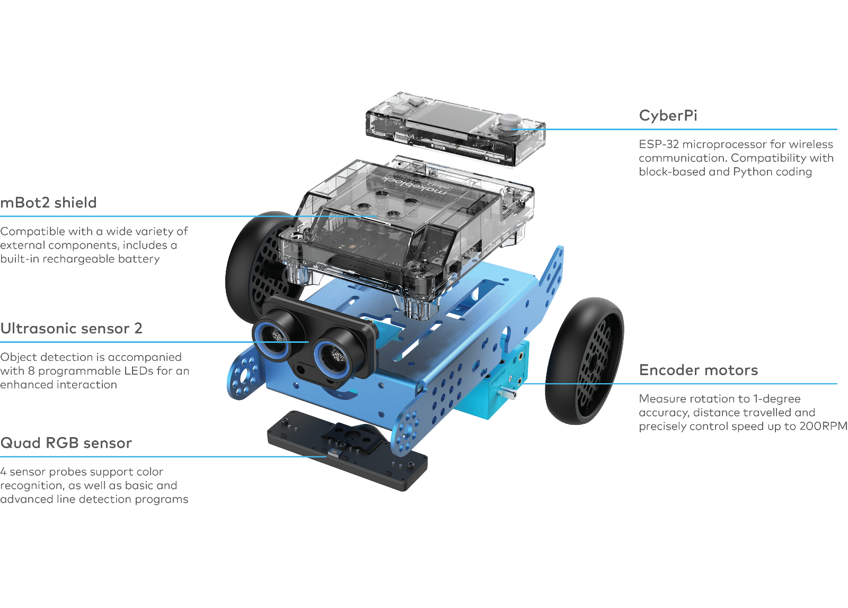

**2.1 Encoder Motors**

mBot2 motors are equipped with optical encoders that enable high accuracy control. With this, students can precisely control the rotation, speed and position of the wheels and the robot. Additionally, the motors can also be used as servos, and even as knobs, to feedback data to the system, just like a sensor.

Thanks to these features, lessons can be more realistic and educational in comparison with robots that have less control of their motors. Activities can do a proper integration of Maths concepts, for instance, by driving precise distances, calculating exact turns and even mapping a route through a maze and transferring the results back to the computer.

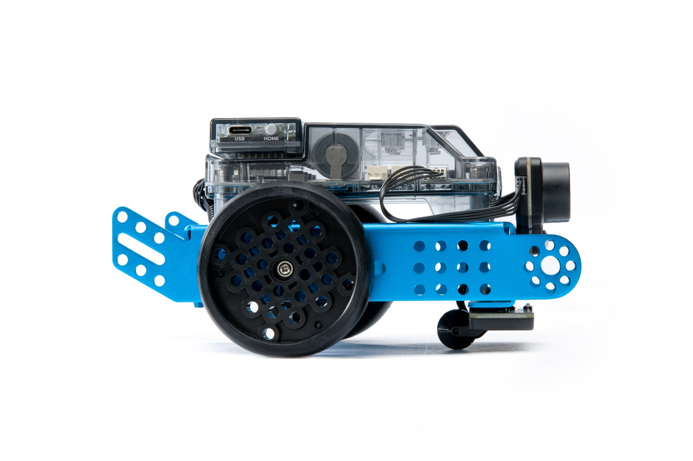

Lesson 1 from the Getting Started Activities offers an introduction to the different coding blocks for the Encoder Motors in the programming environment mBlock, as well as an easy assignment for students to explore the possibilities by themselves.

**2.2 Ultrasonic sensor and Quad RGB sensor**

The ultrasonic sensor that comes with the mBot2 can perform more accurate and consistent readings than its predecessors. Additionally, it incorporates blue LEDs that support new ways of interaction with the robot. Students can use these additional lights to display responses.

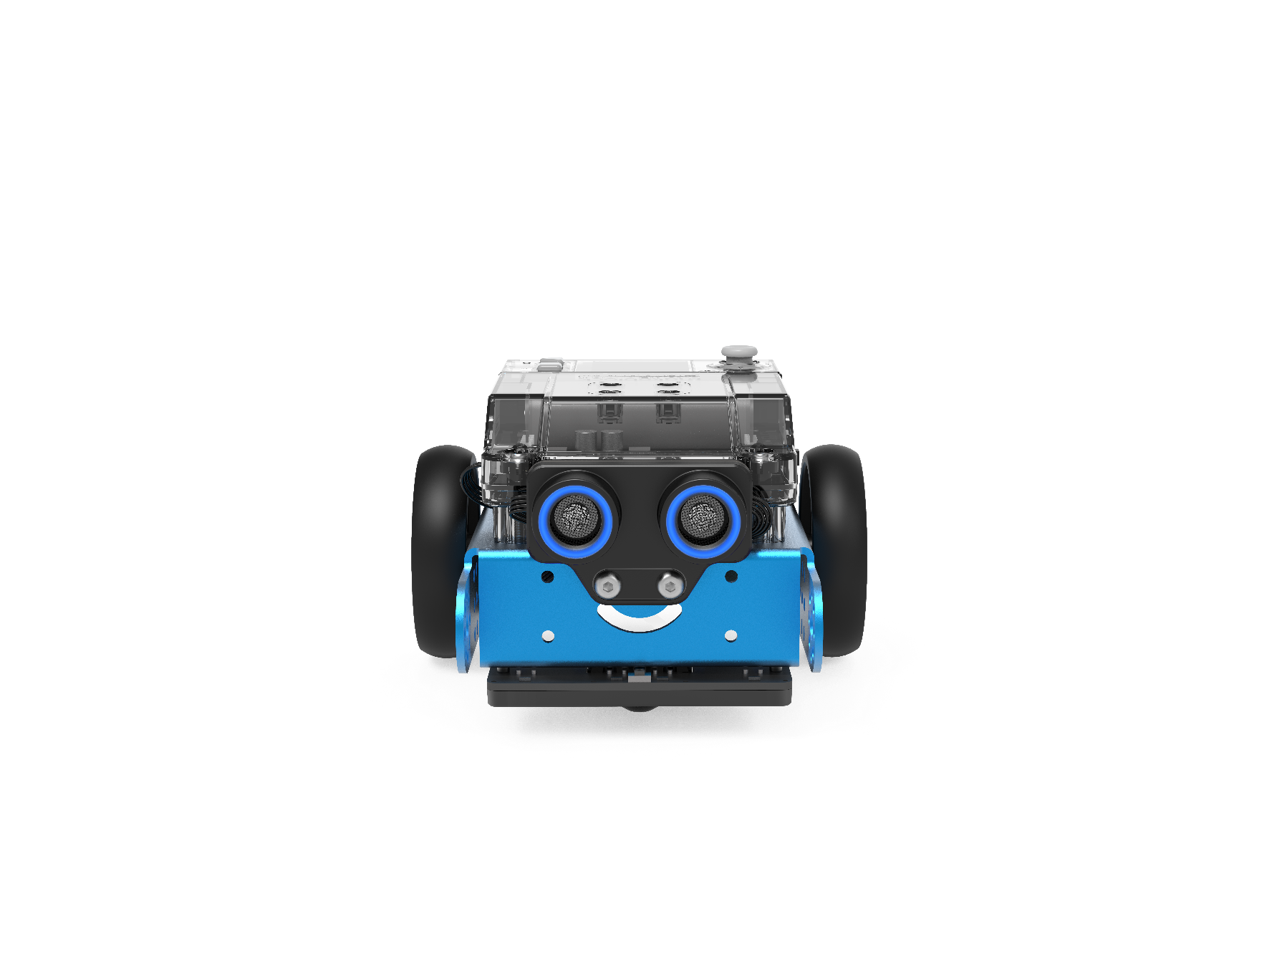

mBot2 integrates another advanced component: the Quad RGB sensor. This sensor has the capacity to not only identify colors, but also to track lines in order to help the mBot2 follow paths, or detect junctions or 90° turns - all at the same time.

The basic functions can be carried out with little prior knowledge, but due to its advanced features, it’s important to know what are the best practices in order to make the most out of the sensor.

Instead of using 2 sensors to track a single line in front of the robot, the Quad RGB sensor has 4 sensors that allow it to identify a broader range of conditions: while following a track, the sensor can identify junctions on the left, right or even both sides, which means that the mBot2 can navigate through more complex maps than other robots. And since each of the four sensors is a color sensor of its own, colored marks can indicate positions on the map – the robot “knows” its location.

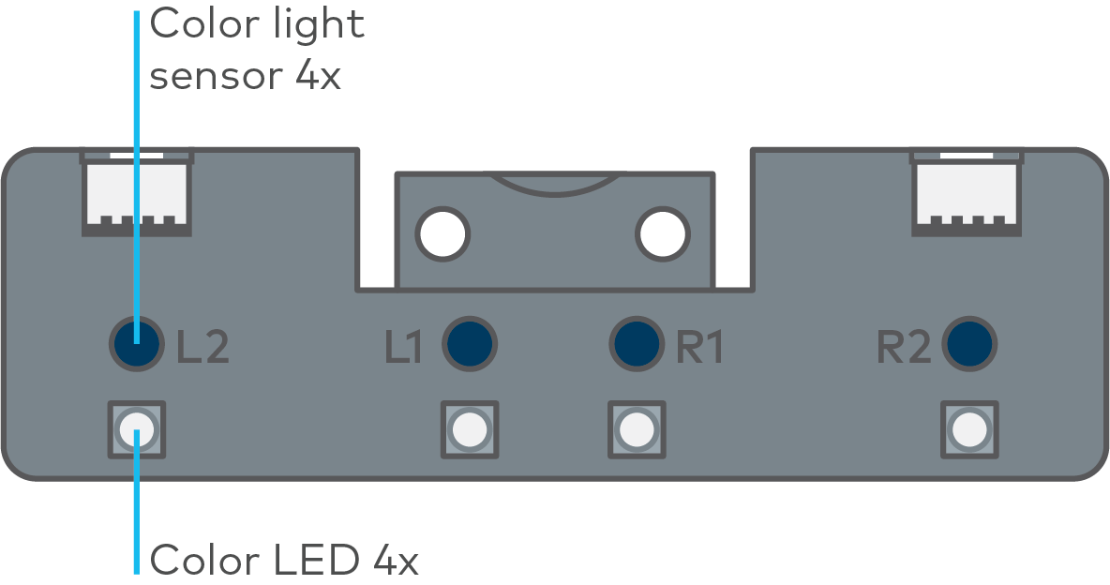

This wider detection range can be used for maps with a network of lines with multiple mBot2s moving between different stations as in a “Smart Warehouse”, or simulate the roads in a city, with its different traffic signals and traffic rules.

Previous line following sensors used infrared light that is not visible to the human eye. These sensors instead operate on a single wavelength, while the new one looks at three different wavelengths simultaneously, just like the human eye: red, green and blue. A mixture of the intensity of theses wavelengths is interpreted by our brain as color perception. The sensor works similar and next to perceiving colors, it tries to differentiate a track from the background for line-following tasks.

With the provided map, we have extra color markers inside the track to trigger additional actions, if programmed accordingly. In order to make the sensor interpret these colors as part of the line, it must be calibrated to the brightest color on the track, which is yellow. Place the sensor over the yellow color code while the mBot2 is switched on and double-click the small button on the top side of the sensor (see the image below). As the LEDs will start flashing, swipe the sensor across the color and white background until the flashing stops (2-3 sec.). After that, the color will be regarded as part of the track (for an in-depth discussion see the additional info on the Quad-RGB-sensor in different environments and lesson 5).

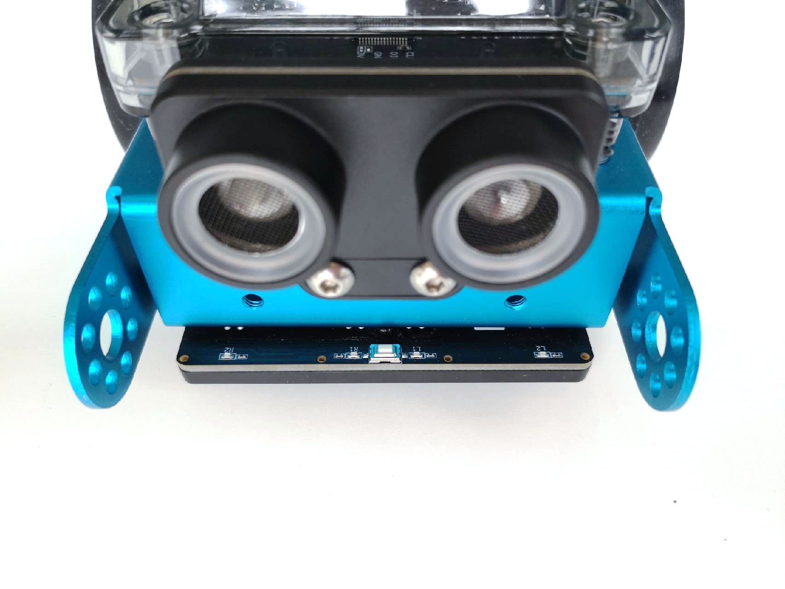

Lesson 5 from the Getting Started Activities provides an explanation of the different blocks that are available in mBlock for the Quad RGB sensor, and students can also practice their learnings with a simple assignment.

**2.3 More possibilities with mBot2**

The scope of activities can be further expanded by combining the mBot2 with the mBuild modules developed by Makeblock Education. Thanks to their internal Micro-Controller Unit (MCU), these smart sensors and actuators can be directly connected without the need of complex wiring or setups, allowing students to spend more time ideating and creating. These components use a single type of connector that can’t be reversed, so students can make no mistakes in connecting them. This gives them more confidence and therefore a better learning experience.

Some examples of the sensors and actuators are: smart camera, multi touch, slider, temperature sensor, etc. With all these sensors, teachers have a variety to choose from for creating real-world scenarios and adjust to teaching and curriculum needs – and students’ interests.

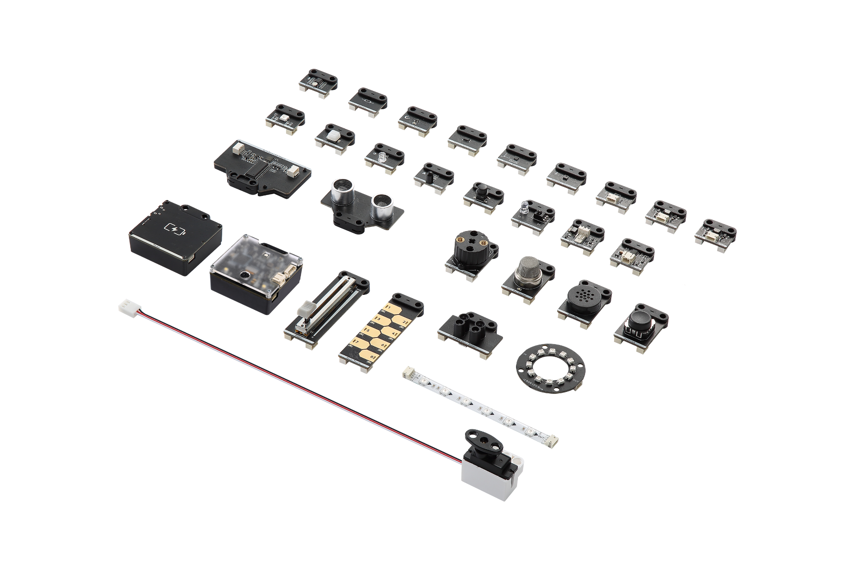

But with the mBot2 alone you already have plenty of opportunities (see the activities), plus the mBot2 Shields offers further connections: the integrated 2-pin and 3-pin interfaces can be used to directly connect DC motors, servos, LED strips, and even third-party components that are commonly available, including a wide variety of Arduino-compatible sensors, or even make custom ones.

**3. Programming mBot2**

mBlock is the coding platform for mBot2, designed to deliver an enhanced educational experience, and a continuous path of growth for the student. Thanks to the extensions in mBlock5, educators can easily include some of the latest and most influential technologies in their lessons, such as the Internet of Things or Artificial Intelligence. Also, by integrating both block-based coding and Python, mBlock5 offers a learning path for students to develop from basic to professional computational skills.

mBlock5 can be used as installed software on computers, laptops, and mobile devices, or on a web browser. It’s compatible with different operating systems such as Windows, Mac, Linux, Chromebook, iOS, Android. Being open source, mBlock5 offers the opportunity to create new extensions for software and hardware, which means that educators can customize the coding tools according to their needs. Users can also search and share projects in the the Makeblock Community.

To start programming with mBlock is as easy as dragging and dropping blocks. The mBlock interface has the following elements:

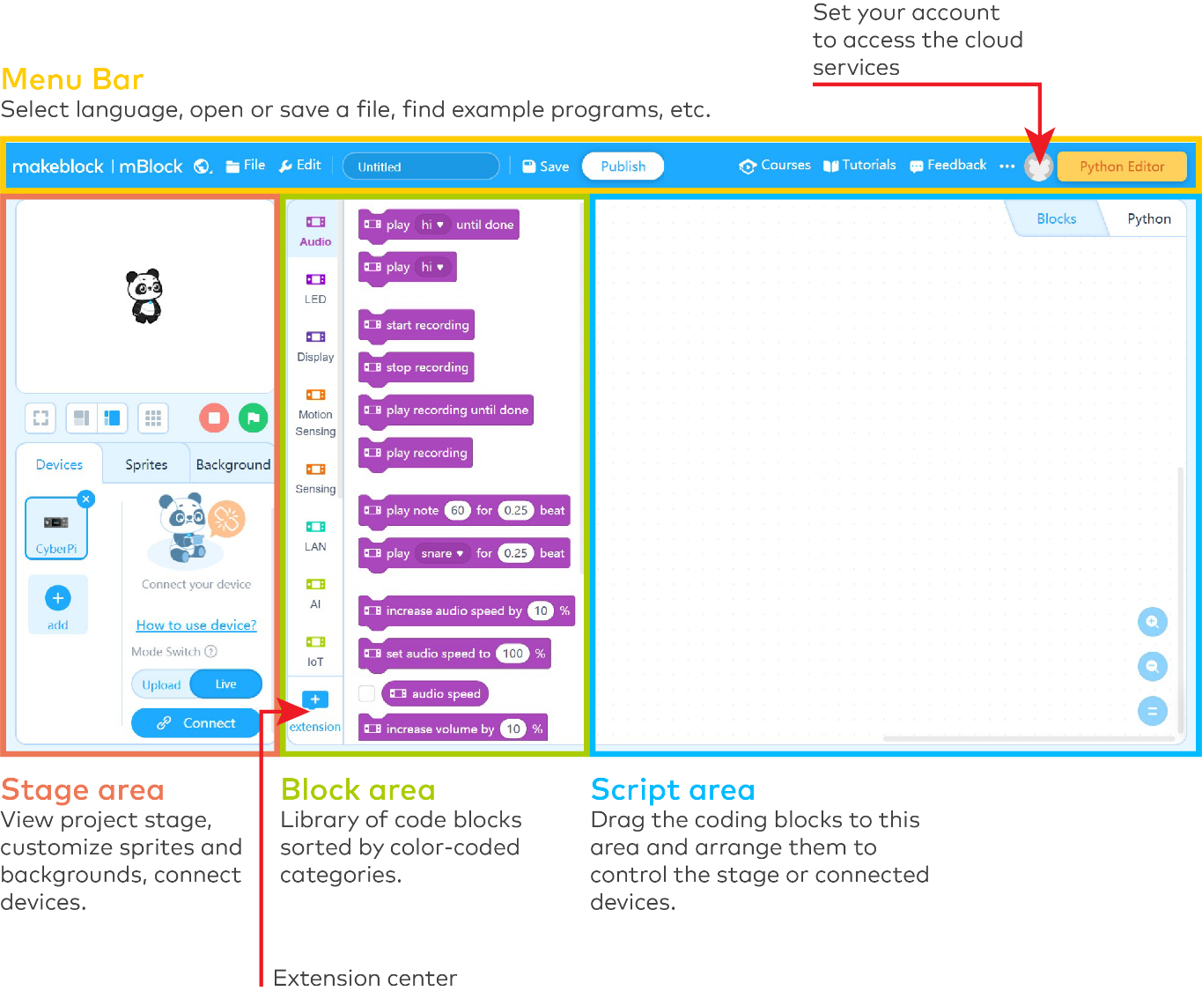

Detailed information about the characteristics and use of mBlock can be found in <https://education.makeblock.com/help/category/mblock-block-based/>

**4. Outline of activities**

The mBot2 Getting Started Activities are developed for students between 11 to 14 years old and their educators. Overall, the lessons are designed to be accessible, despite having different and increasing complexity levels.

Each lesson introduces a different and exciting feature from the mBot2, along with some basic concepts of programming. The knowledge gained from each lesson helps to build towards more advance activities, while the lessons increase in complexity as the learner moves on. For example, the movements of the robot are introduced in Lesson 1 and this is used in many of the subsequent lessons. The possibilities of the Quad RGB sensor are presented in lesson 5, to be later used in lesson 8.

The lessons are briefly described below:

|  |  |  |
| --- | --- | --- |
| **Activity Name** | **Description** | **Key concepts** |
| 1. Let’s move | Students discover the mBot2 and the mBlock software and learn how to drive the robot with precision. This knowledge will be used in most of the following lessons. Students will also design a simple maze and program the mBot2 to (manually) navigate through it. | Precise movements and corresponding coding blocks. |
| 2. Sensing = data | Students will work with the different sensors integrated in the mBot2; they will learn how to use them with their corresponding code blocks, and to visualize data from the sensors on the integrated full color display. | Mode of operation of the sensors.  Different approaches to display and visualize data on the display.  Differences between Live and Upload mode in mBlock 5. |
| 3. Listen to mBot2 | Students will learn how to control the speaker and microphone with the code blocks in mBlock 5. They will also create a program where the mBot2 plays a recorded sound if it meets a certain condition while driving around. | Text to speech (TTS) and Voice recognition (Speech to Text, STT) using the build-in speaker and microphone. Running multiple tasks side by side. |
| 4. Seeing with sound | Students will learn what ultrasound is, how it is used in a sensor, and they will also create a program to make the mBot2 drive in a loop by turning after detecting obstacles on the road. | Detecting an obstacle or a range by using the ultrasonic sensor. Using loops and conditional statements for making the mBot2 drive while avoiding obstacles. |
| 5. Sightseeing | Students will learn how a color sensor works, how are they used in real life, and they will program the mBot2 to become a tour bus that visits different landmarks in a city. This knowledge will be also applied in lessons 7 and 8. | Mode of operation (physics of light) of the color sensor/line follower. Color and line identification- Making the mBot2 follow a line and having it perform actions based on color detection. |
| 6. Careful drive | Students will learn how to use the gyroscope accelerometer of the mBot2 and its code blocks, and they will program the mBot2 to adjust its driving behavior if it detects inclinations on the road. | Mode of operation of gyroscopes and accelerometers (as Inertial Measurement Units, IMU). Coding the mBot2 to adapt to road conditions based on IMU data. |
| 7. A network game | Students will learn to have multiple mBot2s communicating with each other wirelessly without the need of a WIFI access point. They will program a simple game where multiple mBot2s search for a color and the first one to find it wins. This knowledge will also be used in lesson 8. | Wireless data transfer in ad-hoc networks. Data exchange in loops and events. |
| 8. mBot2 at your service | By learning how to set up a WIFI connection with the mBot2, students will also learn to use onboard speech recognition, and they will apply this knowledge in an activity where the mBot2 becomes a robot waiter who talks to its customers. | Using WIFI infrastructure mode with the mBot2 for speech recognition and speech synthesis. Offloading heavy computing like speech recognition to cloud services. Structuring code by applying “own blocks” (functions). |
| 9. mBot2 in the wild | In this special lesson, students will learn some principles of Artificial Intelligence by using the Teachable Machine extension in mBlock5. They will apply their knowledge to recreate a natural ecosystem where the mBot2 behaves like an animal. | Learning about Machine Learning and applying it with local processing only on block-based programming. Establishing a new communication protocol between the mBot2 and the computer. |

Throughout the lessons students are encouraged, with the consent of educators, to document their learning outcomes by video and publish them, as a way to gain pride of their work and lead their conversation about Computer Science and STEAM in the classroom.